Introduction to Test Suite
OBJECTIVE: Grouping the multiple JUnit test cases and constructing a Test Suite program.
Test suite: Test suite is used to bundle a few unit test cases and run them together. In JUnit,
both @RunWith and @Suite annotations are used to run the suite tests
Lab Task:
Make a class having four functions for determining,
Whether the input integer is odd.
Whether the input integer is even.
Whether the input integer is prime.
For calculating the factorial of that input integer.
Write their test cases and execute them in a single test suite class. Follow all the steps mentioned
above in the manual.
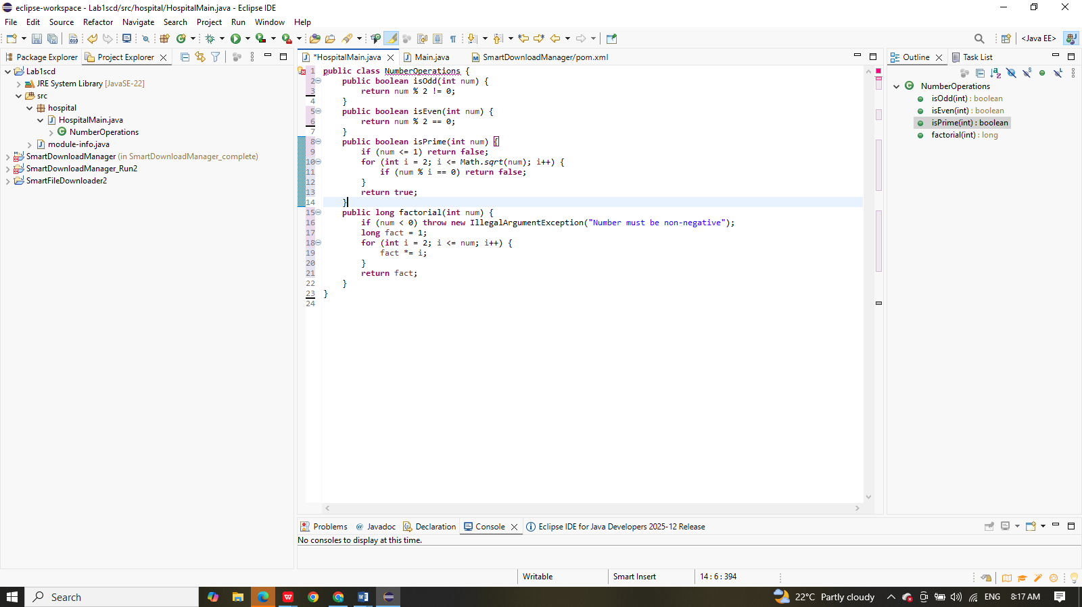
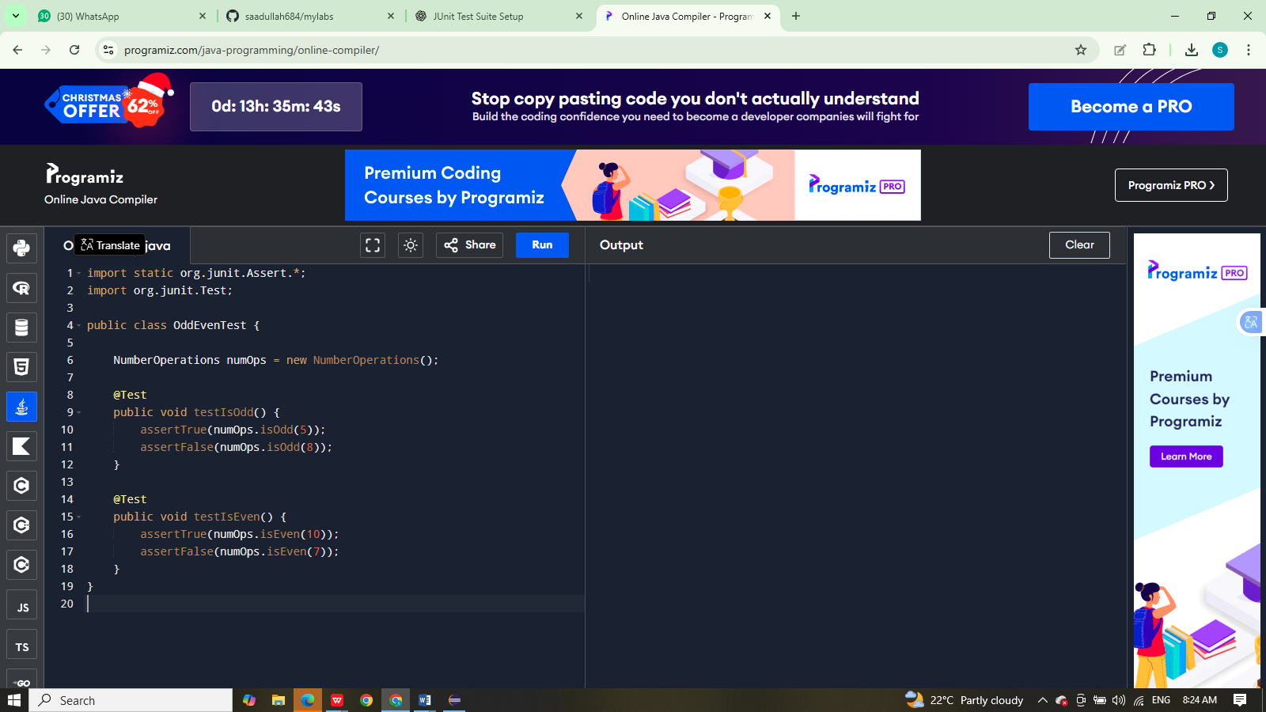
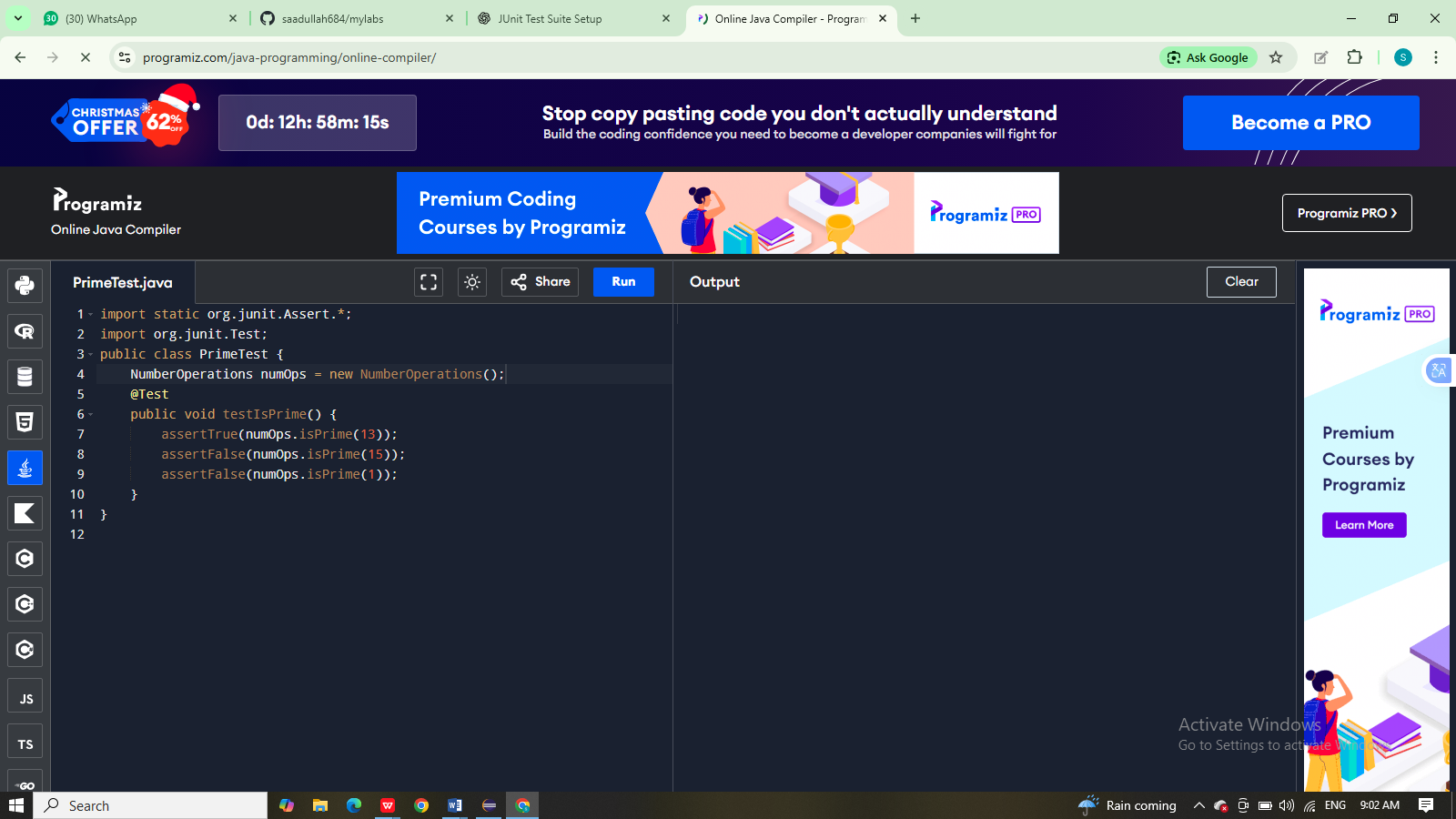
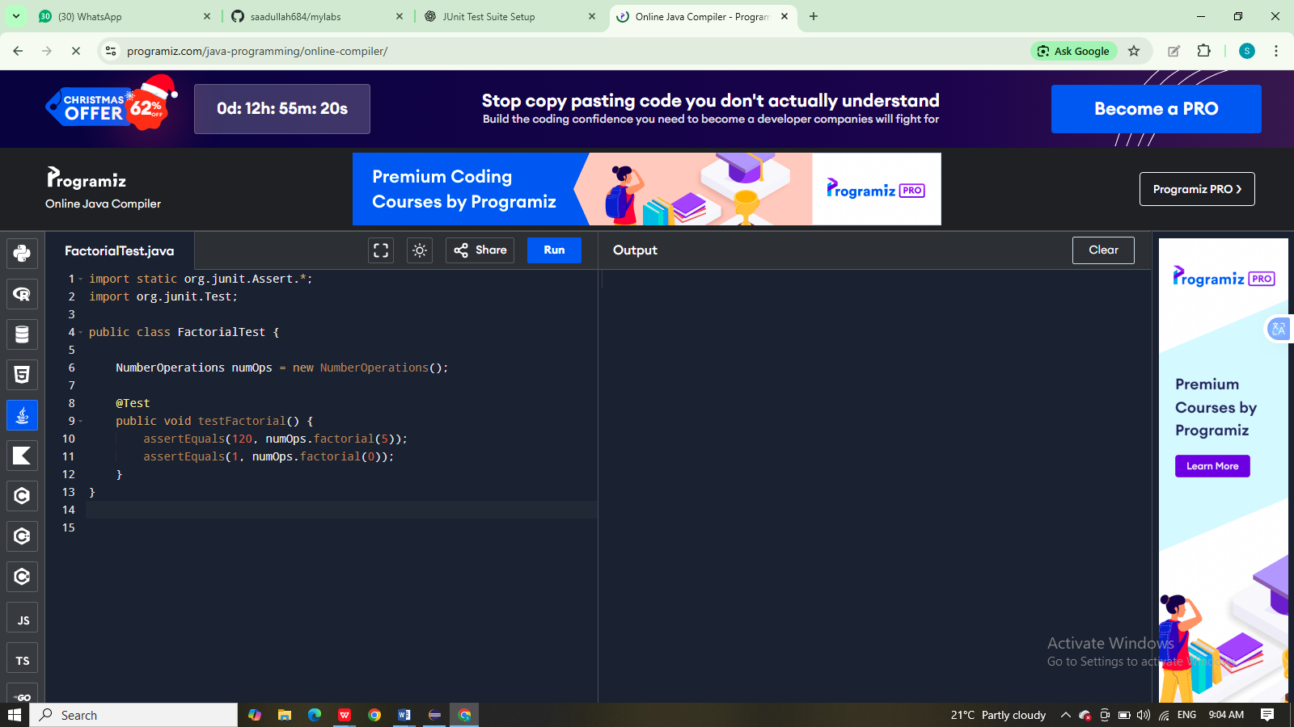
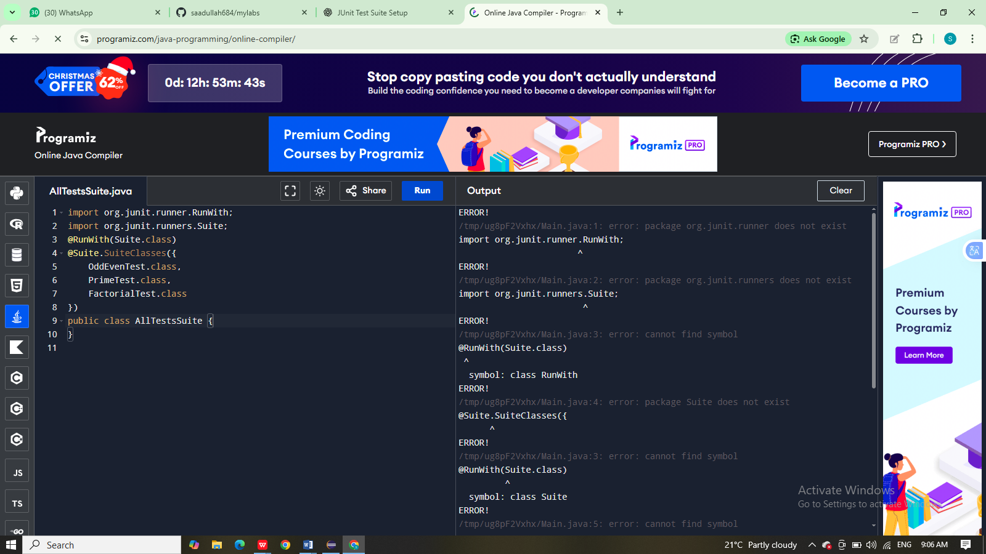
OUTPUT:
